**Form:**

code:

<!DOCTYPE html>

<html lang="en">

<head>

<meta charset="UTF-8">

<meta name="viewport" content="width=device-width, initial-scale=1.0">

<title>Student Registration Form</title>

</head>

<body>

<h2>Student Registration Form</h2>

<form id="registrationForm">

    <h3>Student Information</h3>

    <label for="fullName">Full Name:</label><br>

    <input type="text" id="fullName" name="fullName" required><br><br>

    <label for="email">Email:</label><br>

    <input type="email" id="email" name="email" required><br><br>

    <label for="gender">Gender:</label><br>

    <input type="radio" id="male" name="gender" value="male">

    <label for="male">Male</label>

    <input type="radio" id="female" name="gender" value="female">

    <label for="female">Female</label><br><br>

    <label for="age">Age:</label><br>

    <input type="number" id="age" name="age" required><br><br>

    <label for="country">Country:</label><br>

    <select id="country" name="country">

        <option value="India">India</option>

        <option value="UK">UK</option>

        <option value="Canada">Canada</option>

        <option value="Australia">Australia</option>

        <option value="USA">USA</option>

    </select><br><br>

    <h3>Course Details</h3>

    <label for="courseName">Course Name:</label><br>

    <input type="text" id="courseName" name="courseName" required><br><br>

    <label for="courseRating">How good is the course?</label><br>

    <input type="range" id="courseRating" name="courseRating" min="1" max="10" value="5"><br><br>

    <label for="courseInterest">Your interest level:</label><br>

    <input type="range" id="courseInterest" name="courseInterest" min="1" max="10" value="5"><br><br>

    <label for="courseType">Course Type:</label><br>

    <select id="courseType" name="courseType">

        <option value="online">Online</option>

        <option value="offline">Offline</option>

    </select><br><br>

    <label for="courseDuration">Course Duration (in weeks):</label><br>

    <input type="number" id="courseDuration" name="courseDuration" required><br><br>

    <label for="courseDescription">Course Description:</label><br>

    <textarea id="courseDescription" name="courseDescription" rows="4" required></textarea><br><br>

    <input type="submit" value="Submit"><br><br>

    <input type="button" value="Clear" onclick="clearForm()">

</form>

<script>

    function clearForm() {

        document.getElementById("registrationForm").reset();

    }

</script>

</body>

</html>

Output:

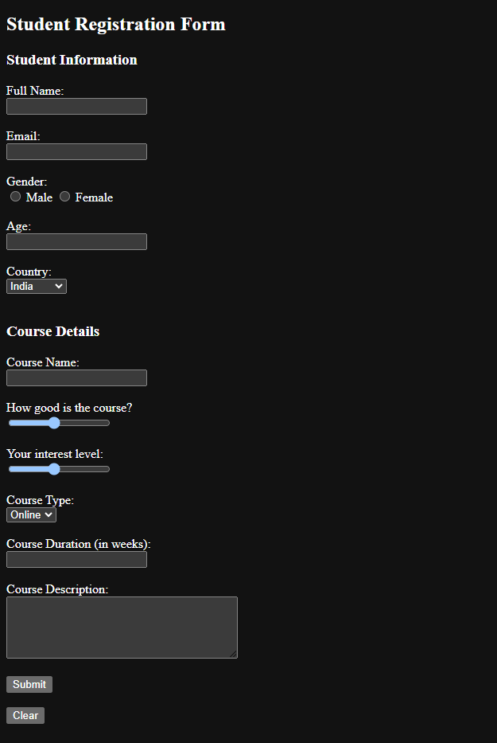

**TributePage:**

**Navbar1.html**

<!DOCTYPE html>

<html lang="en">

<body>

    <main id="main">

        <h3 class="title_att">

            Former President of India

            <br>

            Abdul Kalam

        </h3>

        <h4 class="title_att2">

            1931 - 2015

        </h4>

        </div>

        <p>

        <h4>

        <hr>

        <a href="navbar2.html">Bhagat Singh</a> |

        <a href="navbar3.html">Maharana Pratap</a> |

        <a href="https://www.careerpower.in/freedom-fighters-of-india.html">More Freedom Fighters</a> |

        </h4>

        <hr>

        </p>

        <div id="img">

            <img src="abdul_kalam.jpg" id="image">

        </div>

        <div id="tribute-data">

            <h1 class="title-vk">

                About the Missile Man of India

            </h1>

        <p>

            A.P.J. Abdul Kalam (born October 15, 1931, Rameswaram, India—died July 27, 2015, Shillong) Indian scientist and politician who played a leading role in the development of India’s missile and nuclear weapons programs. He was president of India from 2002 to 2007.

            Kalam earned a degree in aeronautical engineering from the Madras Institute of Technology and in 1958 joined the Defence Research and Development Organisation (DRDO). In 1969 he moved to the Indian Space Research Organisation, where he was project director of the SLV-III, the first satellite launch vehicle that was both designed and produced in India. Rejoining DRDO in 1982, Kalam planned the program that produced a number of successful missiles, which helped earn him the nickname “Missile Man.” Among those successes was Agni,

            India’s first intermediate-range ballistic missile, which incorporated aspects of the SLV-III and was launched in 1989.

        </p>

        </div>

        <br>

    </main>

</body>

</html>

**Navbar2.html**

<!DOCTYPE html>

<html lang="en">

<body>

    <main id="main">

        <h3 class="title_att">

            Freedom Fighter

            <br>

            Bhagat Singh

        </h3>

        <h4 class="title_att2">

            1907 - 1931

        </h4>

        </div>

        <p>

        <h4>

        <hr>

        <a href="navbar.html">APJ. Abdul Kalam</a> |

        <a href="navbar3.html">Maharana Pratap</a> |

        <a href="https://www.careerpower.in/freedom-fighters-of-india.html">More Freedom Fighters</a> |

        </h4>

        <hr>

        </p>

        <div id="img">

            <img src="Bhagat_Singh_1929.jpg" id="image">

        </div>

        <div id="tribute-data">

            <h1 class="title-vk">

                Indian socialist revolutionary

            </h1>

        <p>

            Bhagat Singh (born September 27, 1907, Lyallpur, western Punjab, India [now in Pakistan]—died March 23, 1931, Lahore [now in Pakistan]) revolutionary hero of the Indian independence movement. Bhagat Singh attended Dayanand Anglo Vedic High School, which was operated by Arya Samaj (a reform sect of modern Hinduism), and then National College, both located in Lahore. He began to protest British rule in India while still a youth and soon fought for national independence. He also worked as a writer and editor in Amritsar for Punjabi- and Urdu-language newspapers espousing Marxist theories. He is credited with popularizing the catchphrase “Inquilab zindabad” (“Long live the revolution”).In 1928 Bhagat Singh plotted with others to kill the police chief responsible for the death of Indian writer and politician Lala Lajpat Rai, one of the founders of National College, during a silent march opposing the Simon Commission. Instead, in a case of mistaken identity, junior officer J.P. Saunders was killed, and Bhagat Singh had to flee Lahore to escape the death penalty. In 1929 he and an associate lobbed a bomb at the Central Legislative Assembly in Delhi to protest the implementation of the Defence of India Act and then surrendered. He was hanged at the age of 23 for the murder of Saunders.

        </p>

        </div>

        <br>

    </main>

</body>

</html>

**Navbar3.html**

<!DOCTYPE html>

<html lang="en">

<body>

    <main id="main">

        <h3 class="title_att">

            Freedom Fighter

        <br>

            Maharana Pratap

        </h3>

        <h4 class="title_att2">

            1540 - 1597

        </h4>

        </div>

        <p>

        <h4>

        <hr>

        <a href="navbar.html">APJ. Abdul Kalam</a> |

        <a href="navbar2.html">Bhagat Singh</a> |

        <a href="https://www.careerpower.in/freedom-fighters-of-india.html">More Freedom Fighters</a> |

        </h4>

        <hr>

        </p>

        <div id="img">

            <img src="maharana_pratap.jpg" id="image">

        </div>

        <div id="tribute-data">

            <h1 class="title-vk">

                Ruler of Mewar

            </h1>

        <p>

            Rana Pratap Singh (born 1545?, Mewar [India]—died January 19, 1597, Mewar) Hindu maharaja (1572–97) of the Rajput confederacy of Mewar, now in northwestern India and eastern Pakistan. He successfully resisted efforts of the Mughal emperor Akbar to conquer his area and is honoured as a hero in Rajasthan.

            The son and successor of the weak Rana Udai Singh, Rana Pratap sought to avenge the 1567 pillage of his capital, Chitor, and subsequent raids by Akbar; this was in notable contrast to his fellow Hindu princes, who had submitted to the Mughals. Rana Pratap reorganized the government, improved the forts, and directed his subjects to take refuge in the mountain country when attacked by Mughals. After insulting one of Akbar’s emissaries and refusing an alliance, he was defeated in June 1576 by Mughal forces at Haldighat and fled to the hills. Despite the loss of many of his strongholds, he continued to harass the Mughals and urged noncooperation and passive resistance to Akbar’s tax collectors.

            In the meantime, Mewar declined to a wasteland.

        </p>

        </div>

        <br>

    </main>

</body>

</html>

**OUTPUT:**

